Biodata of Dr. Masahiro Oikawa

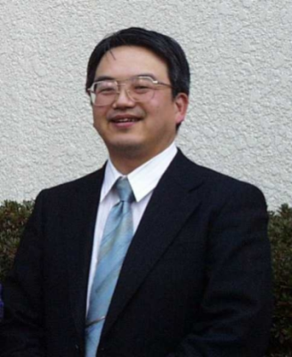 | Dr. Masahiro Oikawa has a superior experience both in his research life and industrial life.  He was born 1957 in Chiba Prefecture, Japan.  He got his Doctor degree of Engineering 1984 from Tokyo institute of Technology in 1984. In his research at Tokyo Institute of Technology, he invented Planar Micro Lens (PML) Array that is two-dimensionally integrated microlenses on a glass substrate.  1984-1991  After he joined Nippon Sheet Glass Co., Ltd (NSG), he made the planar microlens as commercial products. The microlens array is applied for coupling lenses for optical interconnection modules of parallel optical communication. Also the microlens array was applied in LCD projection TV set. That is used to improve the brightness of projection TV set. The sales account of the planar microlens was achieved several million US$ per year.  1992-2000  After he succeeded in making the planar microlens as profitable commercial product, he moved into the sales group of NSG as a marketing director to lead a strategic planning of optics division of NSG.  He made a strategic business plan of Epitaxx Inc. (USA) that NSG accrued to make a new business activity in the optical communication area.  In the sales group he also made the strategic sales alliance with JDSU to introduce their product into Japanese market.  2000-2008  Beside he is persuading the strategic marketing in the sales group, he helped planning division of NSG in terms of investor relation (IR). He experienced that by explanation of the company strategy in the field of growing area such as optical fiber communication business, the stock price of company can rise ten-times (bubble economy).  2009-present  He joined Optohub Co. Ltd., a venture company of optical communication and optical measurement equipments. In Optohub Co. Ltd. he is also doing strategic marketing to find the growing business area.  2012-present  He supported the formation and is being the advisor of John Batubara & Associates Education Consulting, Indonesia.  Hobby: Music to play piano and flute. Taking photo.  Family: One wife, two daughters and one son.

Host: John Batubara & Associates Education Consulting
Jalan Sulawesi 11, Lippo Karawaci Utara, Tangerang, Indonesia.

